Mental Health Carers Voice

Strategic Plan 2020 – 2023

Vision
A Canberra that recognises, values, and includes mental health carers.
Principles and Values
Mental health carer wellbeing is central.
Effective advocacy leads to reform.
Informed by mental health carer experience and evidence-based research.
Carer focused decision making.
Mental health carers are informed and central to Mental Health Carer Voice’s work.

Goals
Mental health carers are safe in their homes.
Mental health services recognise, include and value carers.
Mental health services are high quality and available when needed.
Mental health carers have good outcomes on the Wellbeing Indicators.
Mental health carers are engaged in their workplace and education.
Awareness of mental health caring increases in the community.
Mental health carers have an identity outside of caring.

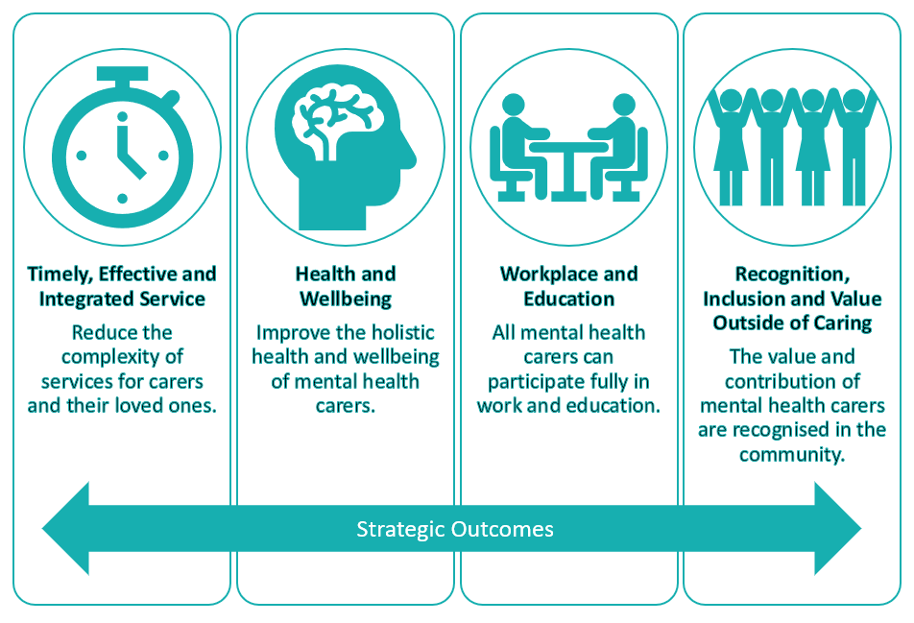
Background
Mental Health Carers Voice (MHCV) is the Peak Body for Mental Health Carers in the ACT. We also provide limited service provision through the Carers ACT gateway.
The Mental Health Carers Voice Advocacy and Policy Advisory Group (APAG) began in 2018 with a broad mandate to of providing a guiding voice for our Mental Health Carers Voice Peak Body work. MHCV actively engages with mental health carers to have their voice heard and create positive change in the sector through both individual and systemic advocacy.
Over the last two years this strategic plan has developed with significant input from the mental health carers community. APAG periodically conducts surveys in the mental health carers community to provide a basis to distil current problems and major concerns within that community. One overwhelming finding was that carers inevitably put their own concerns behind their concern for those they care for, and in the process suffer high levels of stress, exacerbated by feelings that their efforts are neither recognised nor valued by the wider community.

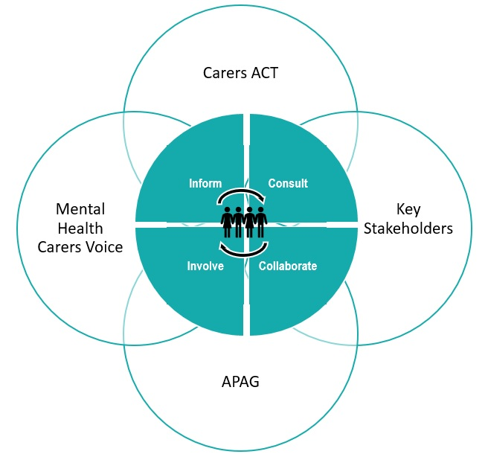

Strategic Plan 2020-2023
Focus One: Timely, Effective and Integrated Services  Reduce the complexity of services for carers and their loved ones. Caring is made more complex because services for both carers and the people they care for are not meeting their needs of being timely, effective and integrated.  Outcomes:  Improve timeliness, effectiveness and integration of services.  Mental health services that recognise, include and value carers in the Triangle of Care.  Mental health services that focus delivery into early intervention.  The quality and quantity of services are suitable for Canberra’s population of mental health service users and carer service users to meet best practice standards (e.g. for wait times, caseloads, patient flow, re-admissions, restrictive practices etc.).  ‘Life services’ involved in the care of a person with a mental illness (e.g. Housing, Medicare, recruitment agencies etc.).  Have mental health carer support services accessible in a manner that meets carers’ needs.  All mental Health Services in the ACT have contract outcome measures on carer inclusivity, reported on as part of the commitment to the ACT Carer Strategy. | Focus Three: Workplace and Education  All mental health carers are able to participate fully in work and education. Caring makes it difficult for mental health Carers to participate in the workforce or education. This can include limited time, but it can also be through stigma and discrimination.  Outcomes:  Remove discrimination and stigma associated with outside work demands on time and emotion. Create a culture of understanding, recognition and value of mental health carers in our community.  Workplace promotion of mental health carers. Improve self-recognition of staff as carers and encourage help seeking behaviours (e.g. use of EAPs and carer support services).  Encourage leave provisions in workforce that match the particular demands of mental health carers.  Schools should engage in outcomes-focused activities to ensure that carers within the education system are being recognised, included and valued, and supported to participate in education.  Encourage universities and further education institutions to provide study patterns that cater to the particular demands of mental health carers.
Focus Two: Health and Wellbeing  Improve the holistic health and wellbeing of mental health carers. Stigma and cultural expectations can make it difficult to disclose being a mental health carer and asking for support for their own physical and emotional needs.  Outcomes:  Improve physical and mental wellbeing of carers.  Include carers as high needs group in Wellbeing Indicators Framework.  Collaboratively engage with the sector to work on concerns for mental health carers’ personal safety, particularly in instances where they are unable to obtain supports for the person they care for and they escalate in the home. | Focus Four: Recognition, Inclusion and Value Outside of Caring  The value and contribution of mental health carers are recognised in the community. Caring can be all consuming and overtime, Carers can lose a sense of identity and purpose outside the caring role.  Outcomes:  Establish pathways for carers to transition out of their caring role to become active and constructive contributors to society in a different way, while recognising their current financial and societal contribution to community.  Promote role of mental health carers in terms of value to community.  Support carer to participate in social events and activities where they share commonalities with participants other than caring.

